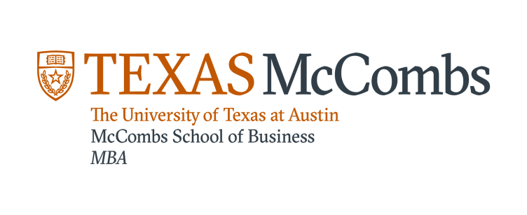

Course Title: MKT 382-Using Analytical Tools for Marketing Decisions
Instructor: Vijay Mahajan

This course deals with concepts, methods, and applications of analytical tools to address such marketing issues as segmentation, targeting and positioning, new product design and development, advertising, and sales force management and promotion planning using a unique online platform called Enginius.biz. The course is designed for MBA students who have some background in or understanding of marketing principles and exposure to spreadsheet programs such as Microsoft excel.

Building on the conventional capstone marketing courses that focus on conceptual material, this course will attempt to provide skills to translate conceptual understanding into specific operational plans -- a skill in increasing demand in organizations today. Using market simulations and related exercises tied to PC-based computer software tools, students will develop marketing plans in various decision contexts.

The course will be of particular value to students planning careers in marketing and management consulting, brand management, client services, and marketing/business analytics.

